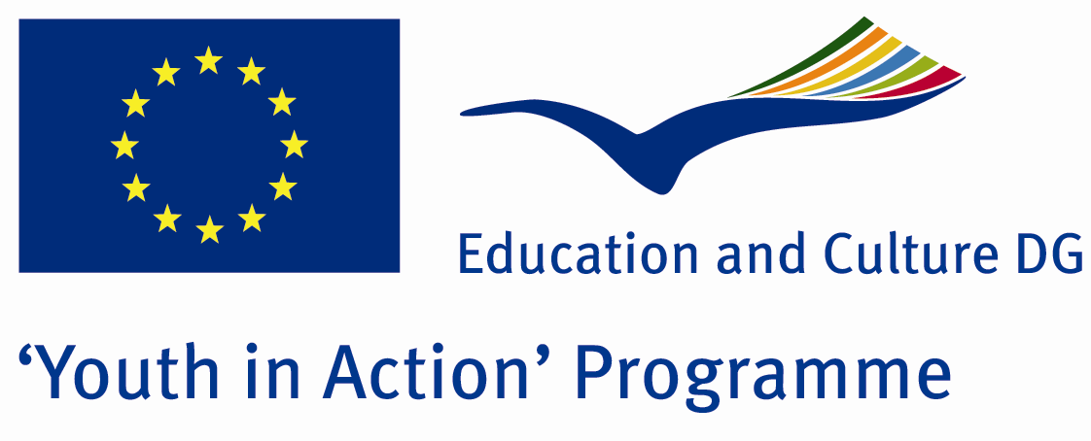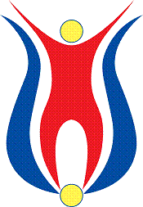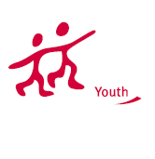

Action 1.1
Project Summary; On paper, men and women always had equal rights. .Someone said that women can not work, read and shut up, no interfere in everything.They said be yourself, often resorted to violence.No one asked why she does well in this situation? We are living in the 21sth century and these are a reflection of our lives and a literal fact.And our goal with this project, we demonstrate this fact and prove that we can change it all together

Project Title; Girls and Boys
Date and Venue ; 02-09 March 2012
Place: Kırklareli, Turkey.

Target Group ; Municipalities, City Councils and Non-Governmental organizations,
youth groups,culture and art groups,e.t.c

Participants ; 5 people from each country (over 18 -25 ). Totally 8 countries.

Conditions ; Accommodation, board and programme costs will be financed through European Commission Youth in Action Programme . Travel costs will be reimbursed in 70% (APEX Tarrifs). Organizations from all 27 EU member countries plus Liechtenstein , Norway and Iceland are eligible to take part.

Working language: English

Organisator group: Eirene Group

How to apply: If you are interested, please send your Part III forms to
by e-mail please (in word file). Scan Part3 format is enough for application.(Fulfilled Part III which you can find in the attachment, of course signed and stamped) ..

Contact e-mail: eirenegroup@gmail.com

